Barthes suggests that rather than being original, writing is a ‘tissue of quotations drawn from the innumerable centres of culture’.

Writing is a tissue of quotations drawn from the innumberable centres of culture

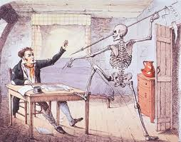

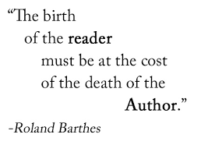

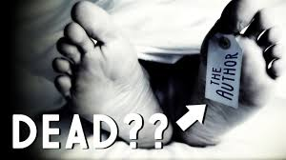

"[T]he writer can only imitate a gesture that is always anterior, never original. His only power is to mix writings [...] in such a way as never to rest on any one of them" (146)

